Anomalous temperature and injury mortality in the USA: age-, sex- and injury-specific impacts: supplementary information

Robbie M Parks^{1,2}, James E Bennett^{1,2}, Helen Tamura-Wicks^{1,2}, Vasilis Kontis^{1,2}, Ralf Toumi³, Goodarz Danaei⁴, Majid Ezzati^{1,2,5*}
¹MRC-PHE Centre for Environment and Health, Imperial College London, London, United Kingdom
²Department of Epidemiology and Biostatistics, School of Public Health, Imperial College London, London, United Kingdom
³Space and Atmospheric Physics, Imperial College London, London, United Kingdom
⁴Harvard T.H. Chan School of Public Health, Boston, Massachusetts, USA.
⁵WHO Collaborating Centre on NCD Surveillance and Epidemiology, Imperial College London, London, United Kingdom

Robbie M Parks: robbie.parks@imperial.ac.uk
James E Bennett: j.e.bennett@imperial.ac.uk
Helen Tamura-Wicks: helen.tamura-wicks07@imperial.ac.uk
Vasilis Kontis: v.kontis@imperial.ac.uk
Ralf Toumi: r.toumi@imperial.ac.uk
Goodarz Danaei: gdanaei@hsph.harvard.edu
Majid Ezzati: majid.ezzati@imperial.ac.uk

*corresponding author:
Majid Ezzati
Imperial College London, Norfolk Place, London W2 1PG, UK
Tel: +44 (0)20 7594 0767

Supplementary Figure 1. Percent change in death rates in year in which each month was +1°C compared with 1980-2009 norm temperatures by type of injury, sex and age group.

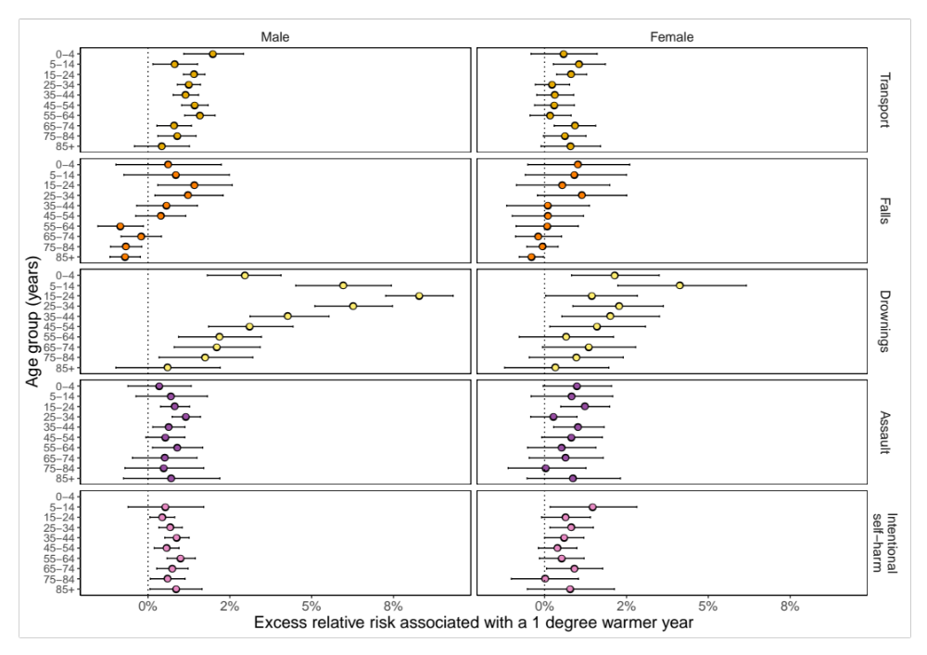

Supplementary Figure 2. Percent change in death rates in year in which each month was +1°C compared with 1980-2009 norm temperatures by type of injury, sex and month.

Supplementary Table 1. Injury groups used in the analysis with ICD-9 and ICD-10 codes.
Injury type | ICD-9 | ICD-10
All injuries | E800-E999 | V0-Y89
Unintentional | E800-E949, E980-E989 | V0-V99, W0-99, X0-X59,  Y10-Y34, Y40-Y89
Transport | E800-E807, E810-E838, E840-E849 | V0-V99
Falls | E880-E888 | W0-W19
Drowning | E910-E910 | W65-W74
Intentional | E950-E979.9, E990-E999 | X60-X99, Y0-Y9, Y35-Y39
Intentional  self-harm | E950-E959 | X60-X84
Assault | E960-E979, E990-E999 | X85-X99, Y0-Y9, Y35-Y39

Supplementary Table 2. Correlation coefficients between monthly anomalies generated from daily mean temperature and daily maximum and minimum temperatures. Each correlation coefficient was calculated in each state for each month for 1980-2016, then averaged over all states for each month.

Month | Mean daily temperature  and  maximum daily temperature | Mean daily temperature  and  minimum daily temperature
January | 0.98 | 0.98
February | 0.98 | 0.98
March | 0.97 | 0.97
April | 0.97 | 0.96
May | 0.96 | 0.94
June | 0.95 | 0.92
July | 0.97 | 0.94
August | 0.96 | 0.93
September | 0.93 | 0.91
October | 0.91 | 0.93
November | 0.96 | 0.97
December | 0.97 | 0.98

Supplementary Table 3. Correlation coefficients between anomaly of mean daily temperature and measures of extreme anomalous temperature described in Methods. Each correlation coefficient was calculated in each state for each month for 1980-2016, then averaged over all states for each month.

Temperature variables | Anomaly of mean (main analysis) | Anomaly of  90th percentile | Number of days  above long-term 90th percentile | Number of 3+ day  episodes above long-term 90th percentile
Anomaly of mean (main analysis) |  | 0.79 | 0.75 | 0.6
Anomaly of  90th percentile | 0.79 |  | 0.89 | 0.77
Number of days  above long-term 90th percentile | 0.75 | 0.89 |  | 0.86
Number of 3+ day  episodes above long-term 90th percentile | 0.6 | 0.77 | 0.86

